
Patuakhali Science and Technology University
Faculty of Computer Science and Engineering

CCE 224 :: Database System Sessional
Sessional Project Report

Project Title : ABC Medical
Submission Date : Sat 16, June 2025

Submitted to,
Prof. Dr. Md Samsuzzaman
Professor,
Department of Computer and Communication Engineering, Patuakhali Science and Technology University.

Submitted by,
Nazmus Sakib
ID : 2102066,
Reg: 10193

Contents
1. Introduction ............................................................................................ 2
2. Objective ............................................................................................... 2
- Technology ............................................................................................. 2
- Database Characteristics .............................................................................. 2
  - Schema Diagram .................................................................................. 3
  - E-R Diagram ...................................................................................... 4
    - Without attributes ......................................................................... 4
    - With all attributes ......................................................................... 4
- Database Implementation ............................................................................. 5
  - DDL ............................................................................................... 5
    - Database Creation ......................................................................... 5
    - Table Creation ............................................................................. 5
      - Users Table ........................................................................ 5
      - Doctor table .................................................................... 6
      - Service Table.............................................................6
      - Doctor Availability................................................................. 6
  - DML (SQL Queries) ............................................................................. 6
    - User Profile ............................................................................... 7
    - Doctor Profile ……………………………………………… 8
    - Buy Medicine ………………………………………………………………………….9
- Limitations ............................................................................................ 9
- Conclusion ............................................................................................ 9
8. References ............................................................................................ 9
ABC Medical

1. Introduction
An SQL learning platform that allows users to learn and practice SQL queries. It it provides a set of features including user registration, problem submission, and a leaderboard. And last but not least, it has built in Blog and chatsheet.

2. Objective
- To create a platform that allows users to learn and practice SQL queries in a fun and interactive way.
- To provide a set of features that will help users to learn and practice SQL queries.
- To create a platform that will help mentors and teachers to help spreading the knowledge of SQL and database management.
- To enable users to share their learningings through blogs and discussions.
- A quick way to find chatsheet and resources related to SQL and database management.

3. Technology
Layer | Technology
Frontend | HTML, CSS & JavaScript
Backend | PHP
Database | MySQL
Authentication | Session storage
Hosting | Localhost, infinityfree

4. Database Characteristics
- CRUD Operations = Create, Read, Update, Delete
- Data Integrity is Enforced through foreign keys and constraints
- Normalization: Applied to reduce redundancy
- Auth Security: Implemented through user authentication and authorization. Mainly session storage is used for user authentication.
- Php PDO driver is used for database interactions, so that it can also connect to other databases like PostgreSQL, SQLite, etc.
- Parameterized arguments were used to prevent SQL injection attacks.
- Database triggers were used to automatically update total_contribution, total_submission and total_solved per user.

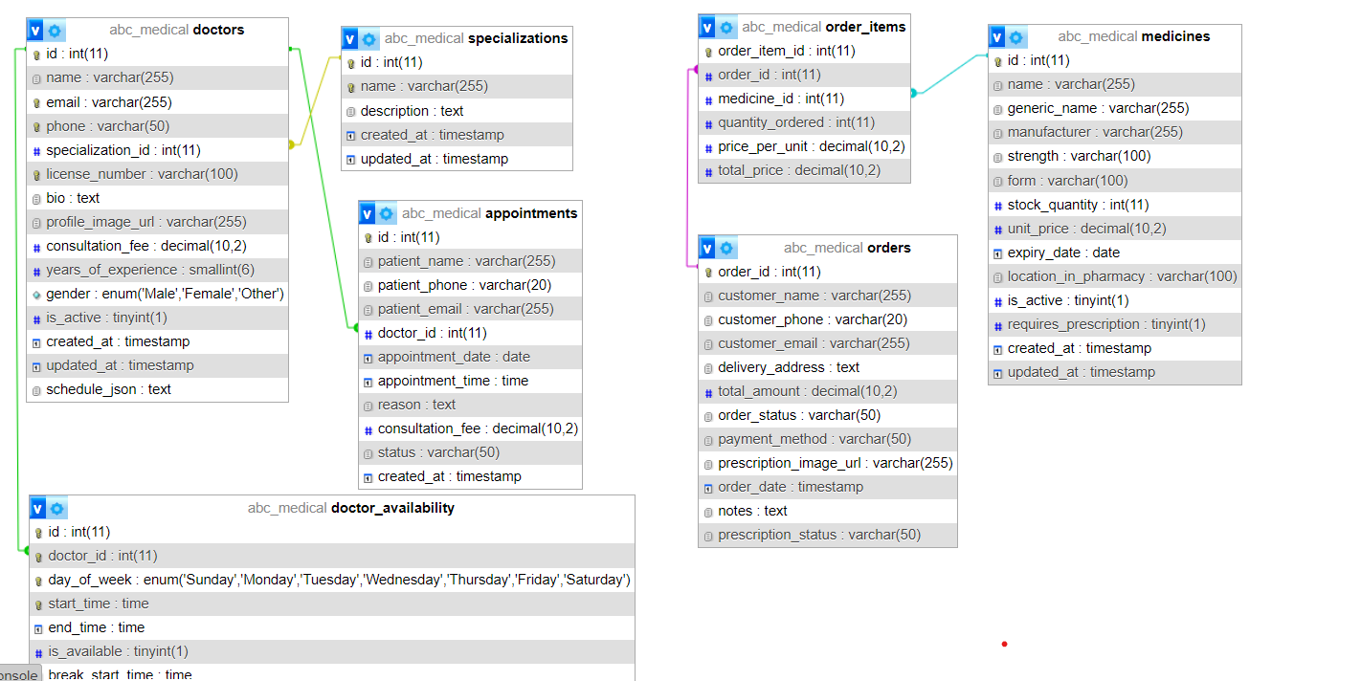
4.1. Schema Diagram

4.2. E-R Diagram
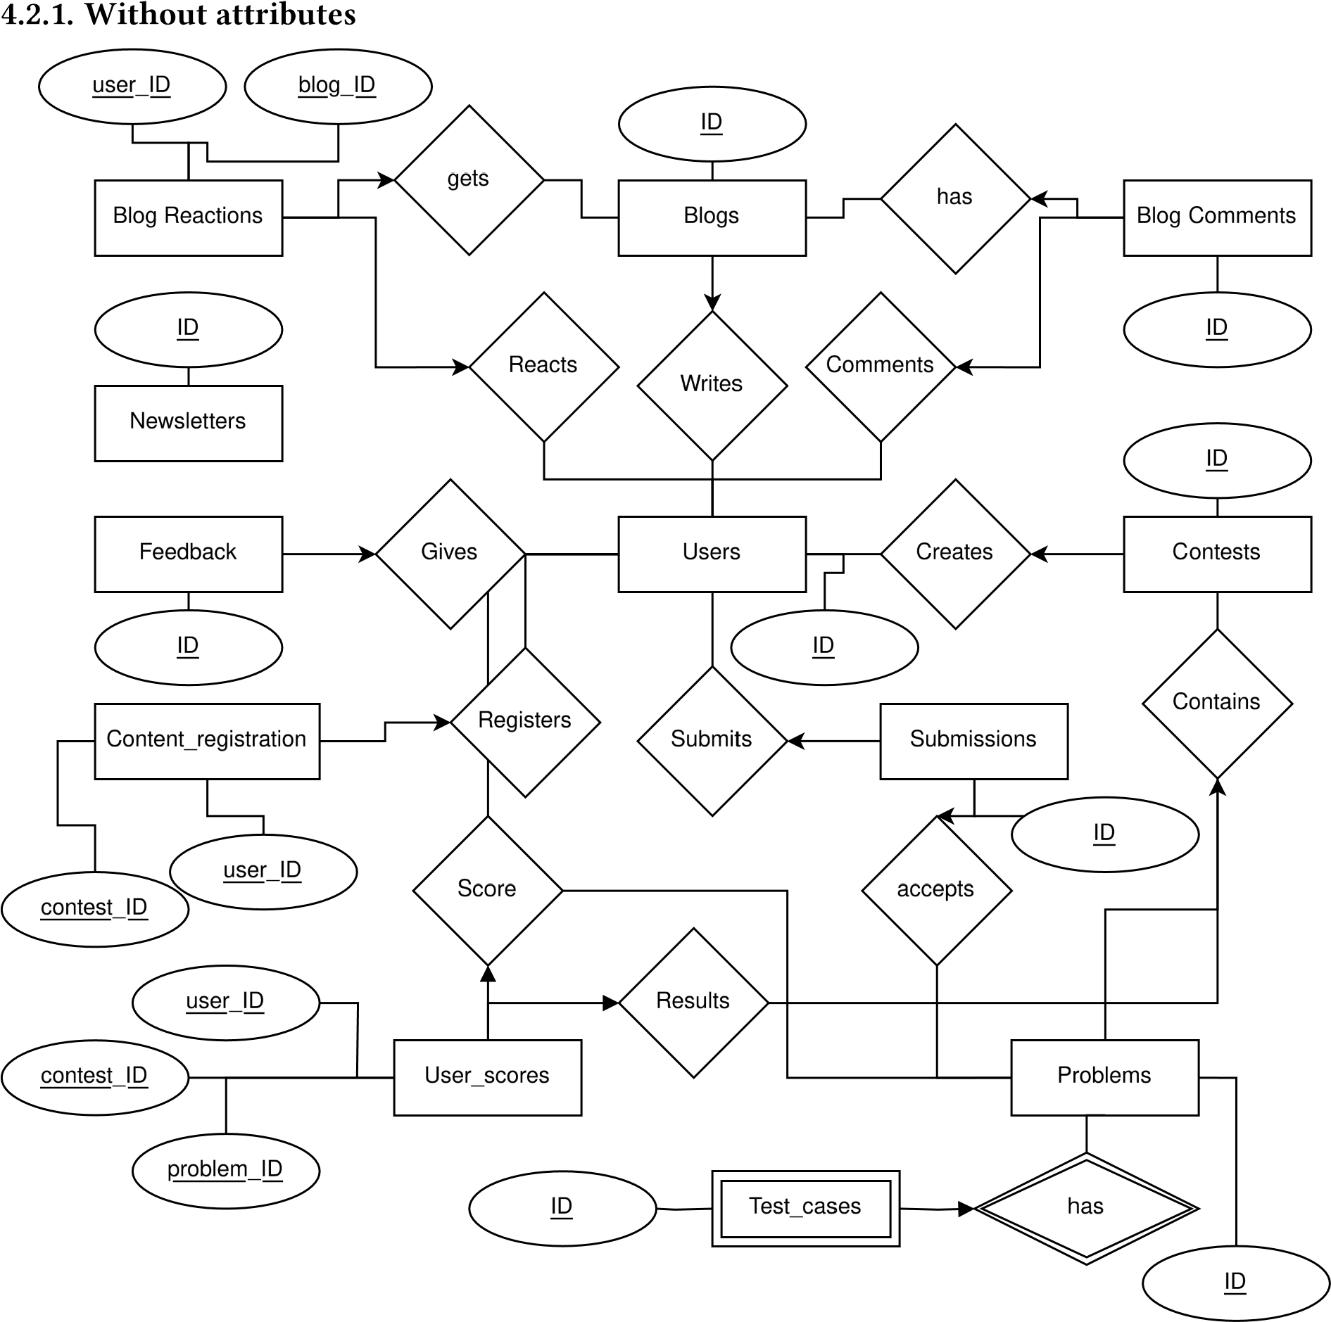

4.2.2. With all attributes
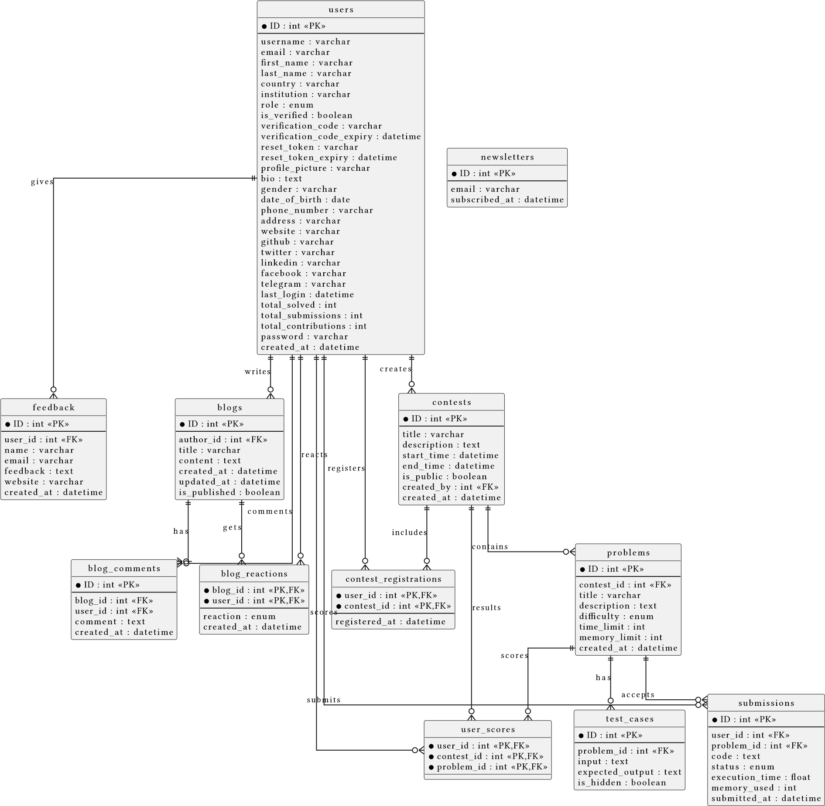

5. Database Implementation

5.1. DDL
Data definition language statements,

5.1.1. Database Creation
CREATE DATABASE IF NOT EXISTS ABC_Medical;
USE abc_medical;

5.1.2. Table Creation

5.1.2.1. Users Table
CREATE TABLE IF NOT EXISTS `users` (
`id` INT AUTO_INCREMENT PRIMARY KEY,
`name` VARCHAR(255) NOT NULL,
`email` VARCHAR(255) NOT NULL UNIQUE,
`password` VARCHAR(255) NOT NULL, -- Store hashed passwords
`role` ENUM('user', 'admin') NOT NULL DEFAULT 'user',
`profile_pic_url` VARCHAR(255) NULL,
`created_at` TIMESTAMP DEFAULT CURRENT_TIMESTAMP,
`updated_at` TIMESTAMP DEFAULT CURRENT_TIMESTAMP ON UPDATE CURRENT_TIMESTAMP
);

5.1.2.3. Doctor Table
CREATE TABLE IF NOT EXISTS `doctors` (
`id` INT AUTO_INCREMENT PRIMARY KEY,
`name` VARCHAR(255) NOT NULL,
`specialization` VARCHAR(255) NULL,
`email` VARCHAR(255) NULL UNIQUE,
`phone` VARCHAR(20) NULL,
`bio` TEXT NULL, -- Optional: A short biography or description
`profile_image_url` VARCHAR(255) NULL, -- Optional
`created_at` TIMESTAMP DEFAULT CURRENT_TIMESTAMP,
`updated_at` TIMESTAMP DEFAULT CURRENT_TIMESTAMP ON UPDATE CURRENT_TIMESTAMP
);

5.1.2.4. Service Table

CREATE TABLE IF NOT EXISTS `services` (

`id` INT AUTO_INCREMENT PRIMARY KEY,

`name` VARCHAR(255) NOT NULL UNIQUE,

`description` TEXT NULL,

`duration_minutes` INT NULL, -- Estimated duration of the service

`base_cost` DECIMAL(10, 2) NULL, -- Optional: base cost for the service

`created_at` TIMESTAMP DEFAULT CURRENT_TIMESTAMP,

`updated_at` TIMESTAMP DEFAULT CURRENT_TIMESTAMP ON UPDATE CURRENT_TIMESTAMP

)

5.1.2.5. Doctor Availability
CREATE TABLE IF NOT EXISTS `appointments` (
`id` INT AUTO_INCREMENT PRIMARY KEY,
`user_id` INT NOT NULL,
`doctor_id` INT NOT NULL,
`service_id` INT NULL,
`appointment_date` DATE NOT NULL,
`appointment_time` TIME NOT NULL,
`status` ENUM('Pending', 'Confirmed', 'Cancelled', 'Completed', 'Rescheduled') NOT NULL DEFAULT 'Pending',
`patient_notes` TEXT NULL,
`doctor_notes` TEXT NULL,
`cancellation_reason` TEXT NULL,
`created_at` TIMESTAMP DEFAULT CURRENT_TIMESTAMP, -- When the appointment was booked
`updated_at` TIMESTAMP DEFAULT CURRENT_TIMESTAMP ON UPDATE CURRENT_TIMESTAMP, -- When the appointment record was last updated

FOREIGN KEY (`user_id`) REFERENCES `users`(`id`) ON DELETE CASCADE,
FOREIGN KEY (`doctor_id`) REFERENCES `doctors`(`id`) ON DELETE RESTRICT, -- Or CASCADE depending on your rules
FOREIGN KEY (`service_id`) REFERENCES `services`(`id`) ON DELETE SET NULL -- Or RESTRICT
);

5.2. DML (SQL Queries)
5.2.1. Authentication

1. User Registration
INSERT INTO users (full name,email address, password)
VALUES (:full name, :email address, :password)
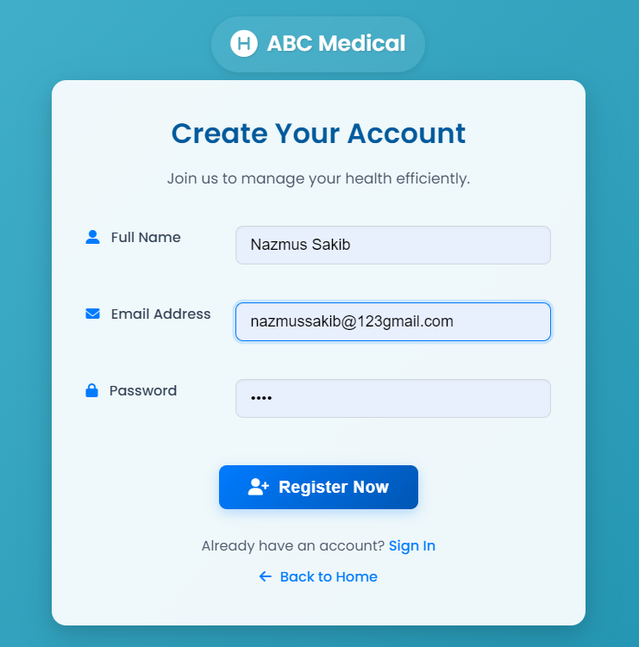

2. User Login
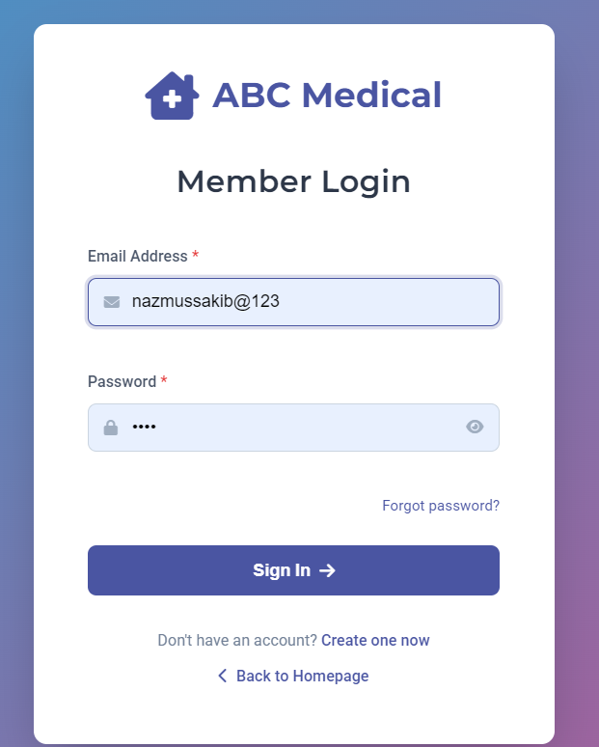
SELECT id, username, password FROM users WHERE username = :username"

3. Check if user already exists
SELECT id FROM users WHERE username = :username"
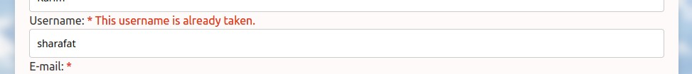

4. Doctor Profile
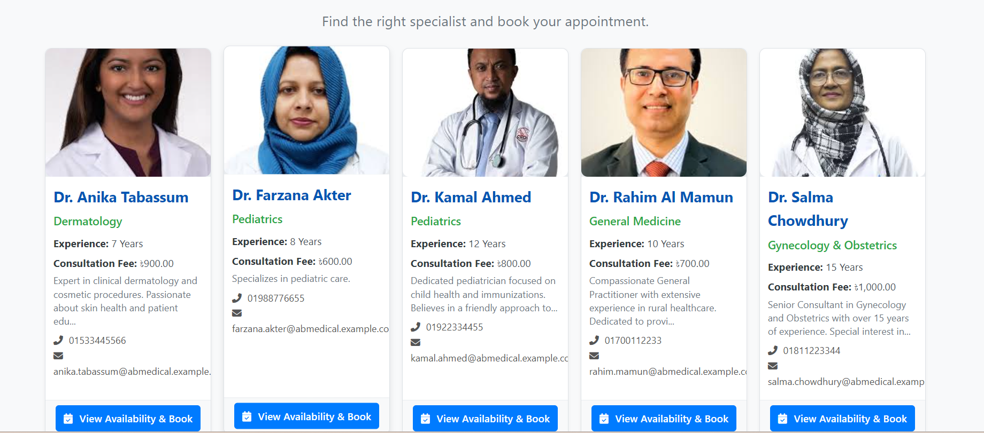

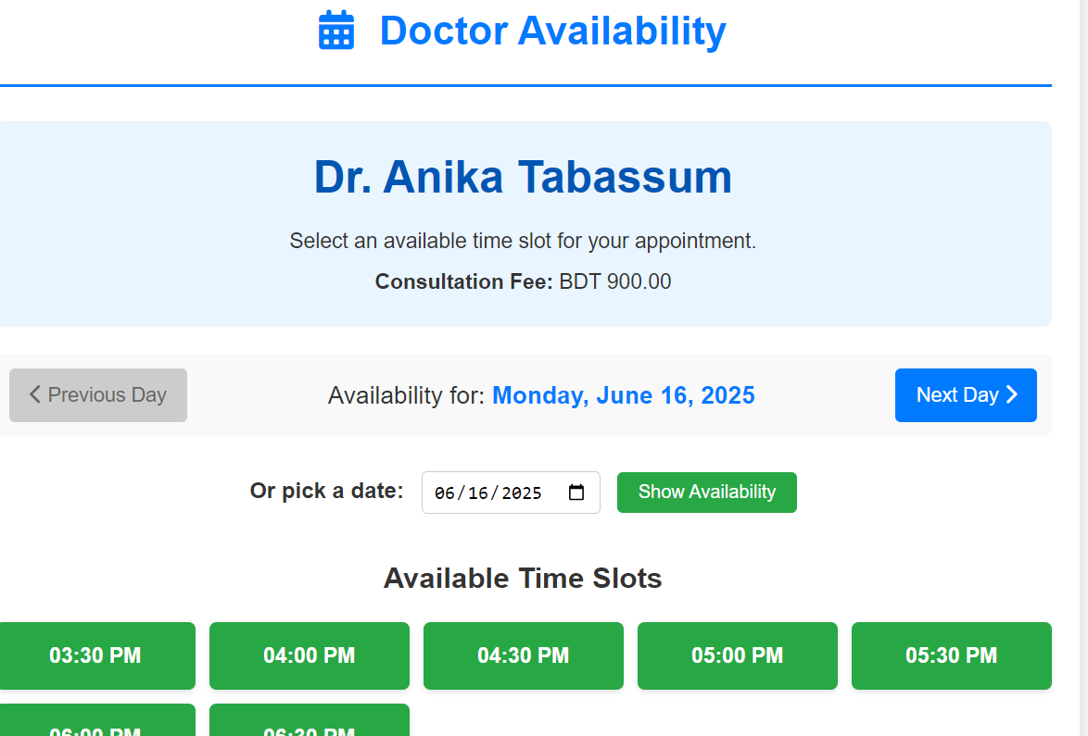
- Doctor Availablity

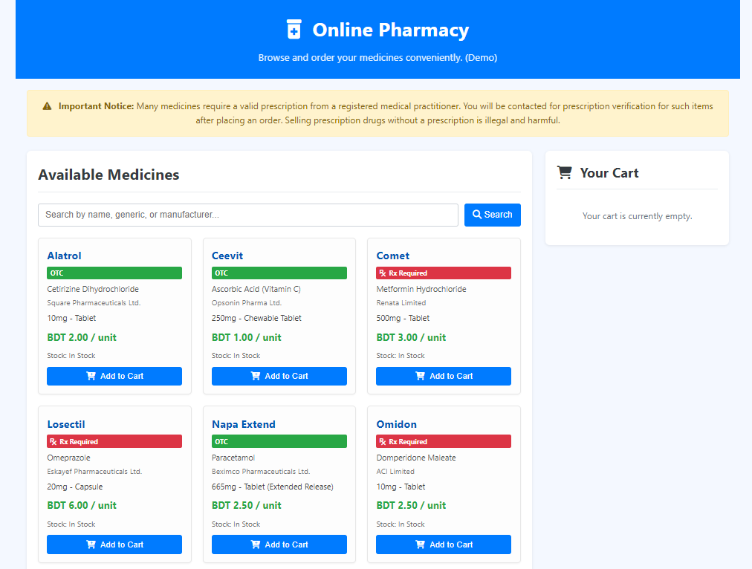
- Buy Medicine

7. Limitations
- The platform is currently hosted on a free hosting service, which may have limitations on performance and uptime.
- Currenty the creator of the contest has to manually review the submissions and update the user scores. This can be automated in the future.
- Markdown editor is not implemented yet, so users cannot format their blogs and comments using markdown syntax everywhere.

8. Conclusion
Finally we can conclude that, SQL Judge platform will help mentors and teachers to help spreading the knowledge of SQL and database management. It will also help students to learn and practice SQL queries in a fun and interactive way. The platform is designed to be user-friendly and easy to navigate, making it accessible to users of all skill levels.

9. References

8.1. Documentations
- https://www.w3schools.com/html/ [W3Schools HTML]
- https://www.w3schools.com/css/ [W3Schools CSS]
- https://www.w3schools.com/sql/ [W3Schools SQL]
- https://www.w3schools.com/php/default.asp [W3Schools PHP]

